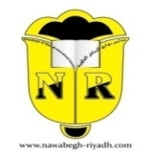
Nawabegh Al-Riyadh International School

Islamic(Non-Arab) Department
Material Covered For the first Quiz – First Semester
Grade (1)

Day/Date | Subject  Grade 5 | Exam Material
 | Islamic  (Non-Arab) | Chapter (1) Allah is One pages 8-10  Chapter (2) Allah is the Creator pages 11-15
Wishing you the best

